

**American International University- Bangladesh**

**CSC 2209: Object Oriented Programming 1 (JAVA)**

**CO1 Evaluation**

**Project Summary Report**

**Fall 19-20**

**Group No: 14**

**Project Title: Hotel Management System**

|  |  |
| --- | --- |
| Student Name | Student Id |
| Suhas Iftakhar | **18-36059-1** |
| Hridoy Chandra Deb | **18-36333-1** |
| Md.Ashraful Alam Shah | **18-36063-1** |
| Nur Hossain | **18-36279-1** |

**Introduction:**

We are doing hotel management system because it helps the authority to easily manage their hotels. In this project we are also making it easier for a customer to reserve a hotel room. Hotel management system is developed to ensure the security and easily accessibility of information of hotels.

**User Category:**

There are two types of Users here. They are:

* Admin
* Employee

**Feature List:**

In this project the “Employee” has the following features:

* Login
* Reservation
* Booking

In this project the “Admin” has the following features:

* Login
* Insert
* Delete
* Update

**GUI Description:**

**1.Login Frame 2.Admin Frame**

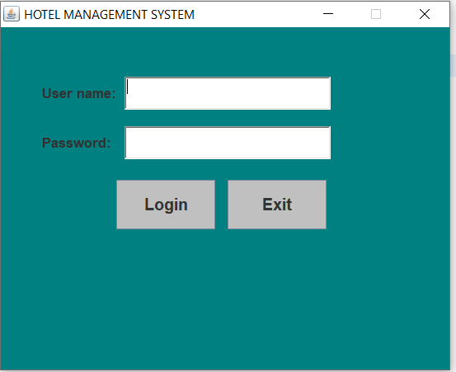 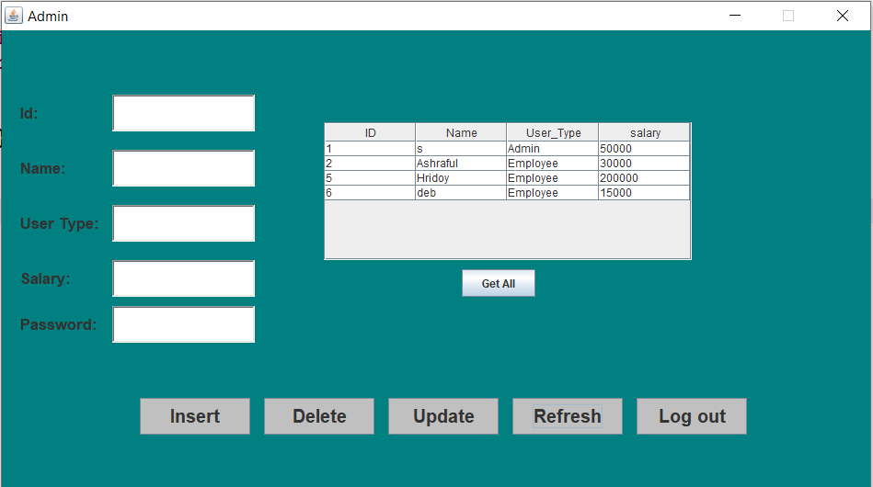

**3.Reservation Frame 4.Booking Frame**

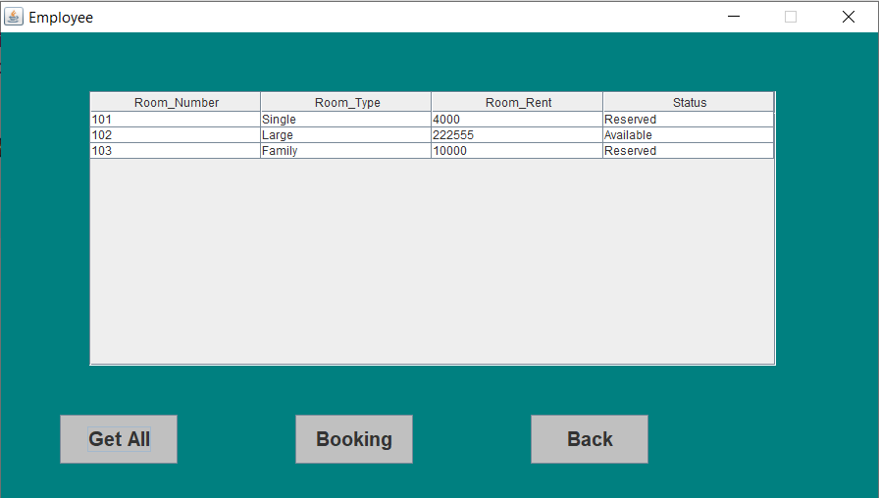 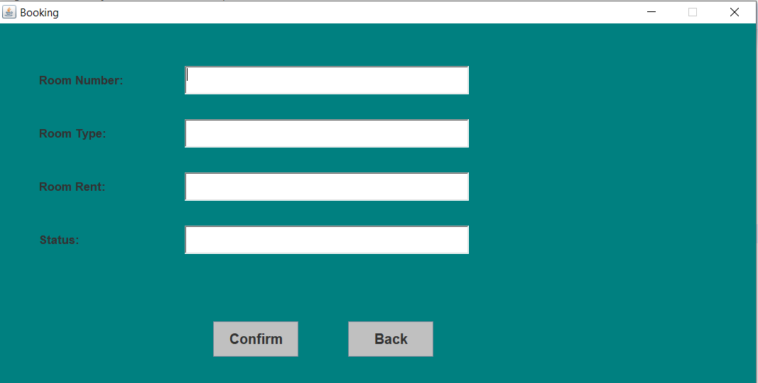

**5.Customer Information**

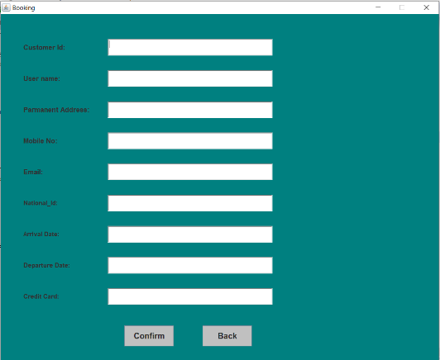

**Database Table Description:**

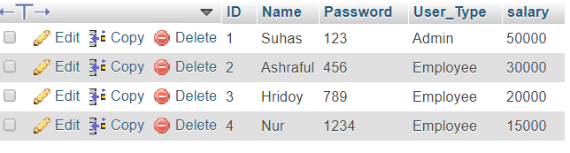

This is the user table.



This is the Customer table.

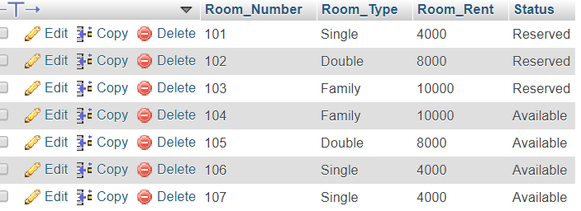

This is the Booking table.

**Class Diagram:**

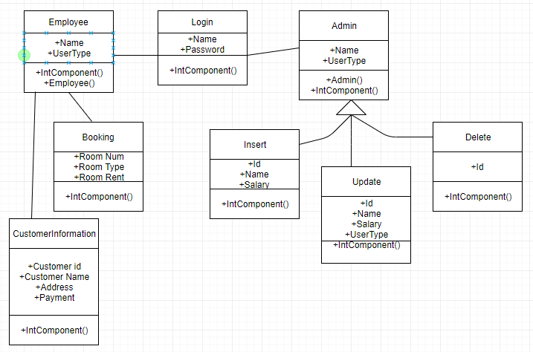

**Tools Used:**

To develop this project we have used the following:

* XAMPP
* Eclipse IDE
* Paint(for color)

**OOP and Java Concepts Used:**

* Inheritance:

We have used inheritance to the class of objects where any subclass that is defined will inherit the definitions of one or more super classes.

* Polymorphism:

The system uses polymorphism by method overloading and method overriding.

* Encapsulation:

It is a protective shield that prevents the data from being accessed by the code outside this shield.

* Interface:

 It is a collection of abstract methods. A class implements an interface, thereby inheriting the abstract methods of the interface.

* AWT:

The awt package provides classes for AWT api such as JText Field, JLabel, JButton,Color etc.

* GUI:In this system , GUI has been used to establish window and toolbars. It gives a reliable user friendly environment without writing any long commands.

**Impact of this Project:**

This hotel management system will provide security to information. It will reduce the risks of lost data of hotels. Management system will become more easy to keep records without using any sort books. It will allow the admin to have up-to-date information regarding all the aspects of their users.

**Limitations and Possible Future Improvements:**

In this system, user can easily book a room by helping Employee.In the future the system will updated so that user can also pay for the rooms from anywhere without any sort of difficulty.